Name: Kanan Ibadzade

Jarred Chen, Efe Gur, Zhi Hao Chong

Behr Free-Fall Lab

**OBJECTIVE**

To analyze the motion of an object in free fall by:

1) Analyzing the corresponding equations of motion.

2) Calculating the velocity at different times by using:

a) the tangent method

b) the equation of motion x = x(t)

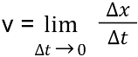 c) graphical methods ( )

3) Calculating the acceleration of gravity ‘g’ and comparing to the expected value of 9.80m/s2.

**THEORY**

Any object moving under the influence of gravity alone, regardless of its initial position, is said to be moving in free-fall. The acceleration of an object in free-fall near the earth's surface is nearly constant and approximately equal to g = 9.80 m/s. In this lab you will analyze the motion of an object moving in free- fall by using an apparatus called the Behr Free-Fall. The object moving in free-fall is a 'bob' that will leave a trail of sparks on a wax paper as it falls through some height H. The sparks will be generated by a spark timer set at a frequency of 60Hz (60 sparks per second). Thus, the trail of sparks on the wax paper will be separated by (1/60) s. Using this information one can obtain data for the position as a function of time for this object in free-fall and use the kinematic equations to analyze its motion.

**APPARATUS**

1. Behr Free-Fall Apparatus

- consists of an electromagnet at the top to hold ‘bob’

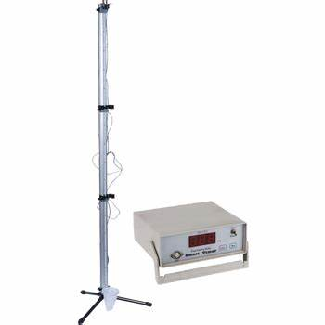

2. Spark Timer

- a device that generates sparks at a frequency of 60Hz.

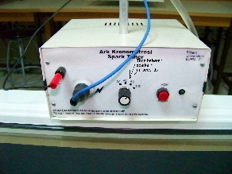

3. Power Supply

- generate electricity

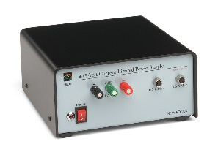

4. Tape

- record the trail of sparks



5. 2-meter stick

- a straight measuring device with a total length of 2 meters and its smallest increment is 1mm

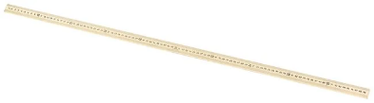

**PROCEDURE**

1. Draw a circle starting with the 2nd or 3rd spark hole. Label this data point Xo. Now draw a circle on every 6th spark hole for a total of 6 data points.

2. Make a graph of x vs. t with EXCEL for the 6 data points.

|  |  |
| --- | --- |
| X (cm) | t (s) |
| X0 | t0 |
| X1 | t1 |
| X2 | t2 |
| X3 | t3 |
| X4 | t4 |
| X5 | t5 |

3. Use EXCEL to obtain the equation of the best curve-fit for x vs. t graph.

4. Calculate V0 at t0, V2 at t2, and V4 at t4 by drawing tangent lines to the curve x(t).

5. Use the equation x = x(t) obtained in (3) to calculate V0, V2, and V4.

6. Calculate the acceleration of the ‘bob’ from the equation x = x(t).

7. Prove algebraically that the graph of Vave vs t is linear and show how the slope is related to the acceleration of gravity ‘g’.

8. Make a graph of Vave vs t using EXCEL and obtain the equation of the best curve fit. Using the above data table, the data points for the graph of Vave vs t corresponding to the following:

|  |  |
| --- | --- |
| Vave | t (s) |
| V01 = (X1-X0)/(t­1-t0) | (t­1-t0) |
| V02 = (X2-X0)/(t­2-t0) | (t­2-t0) |
| V03 = (X3-X0)/(t3-t0) | (t3-t0) |
| V04 = (X4-X0)/(t­4-t0) | (t­4-t0) |
| V05 = (X5-X0)/(t5-t0) | (t5-t0) |
| V06 = (X6-X0)/(t­6-t0) | (t­6-t0) |

9. Calculate the acceleration of the ‘bob’ from the graph of Vave vs t.

10. Calculate the initial velocity V0 of the ‘bob’ from the graph of Vave vs t.

11. Calculate instantaneous velocity of the ‘bob’ V4 at t4 graphically.

12. Calculate instantaneous velocity of the ‘bob’ V2 at t2 graphically.

13. Compare two calculated accelerations of the ‘bob’ to the expected value of g = 9.80 m/s2.

14. Compare the velocities at t0, t2, and t4 using the 3 different methods.

15. Prove that if the acceleration is constant, then Vave over a time interval is equal to Vins at the midpoint of the time interval.

**DATA**

|  |  |
| --- | --- |
| X (cm) | t (s) |
| 0 ± 0.05 | 0 |
| 11.95 ± 0.05 | 0.1 |
| 33.55 ± 0.05 | ­0.2 |
| 64.75 ± 0.05 | 0.3 |
| 98.25 ± 0.05 | 0.4 |
| 147.75 ± 0.05 | 0.5 |

|  |  |
| --- | --- |
| Vave (m/s) | t (s) |
| 1.195 | 0.1 |
| 1.678 | 0.2 |
| 2.158 | 0.3 |
| 2.456 | 0.4 |
| 2.949 | 0.5 |

**GRAPHS**

1. x vs. t

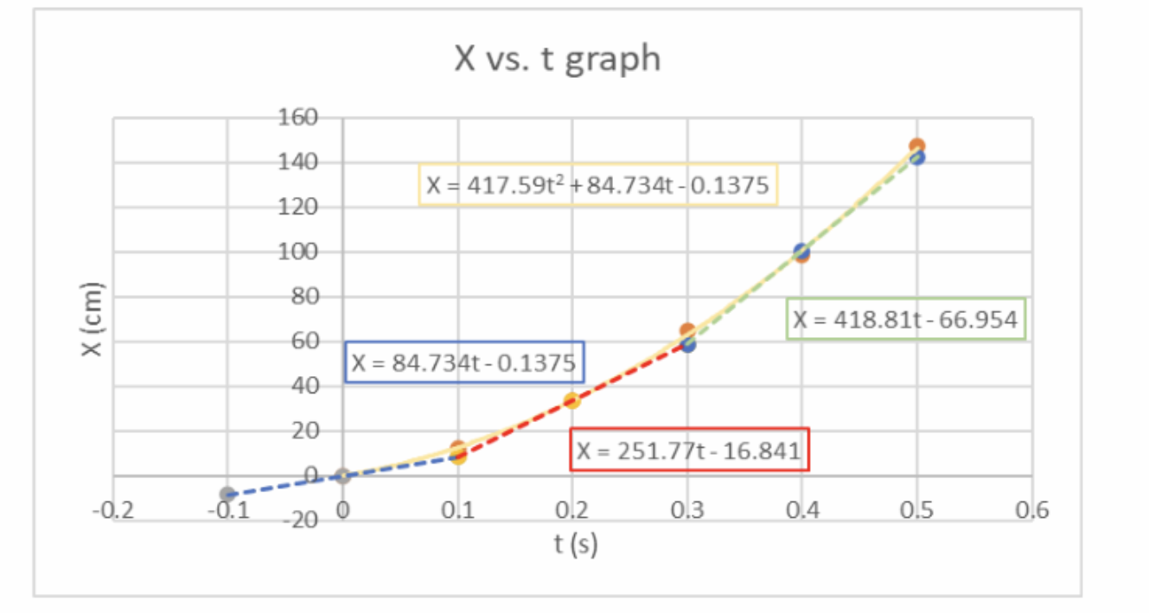

2. Vave vs. t

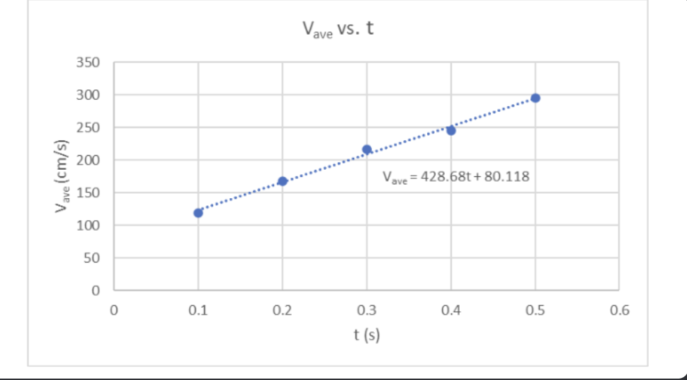

3. Vave vs. t for V2 at X2

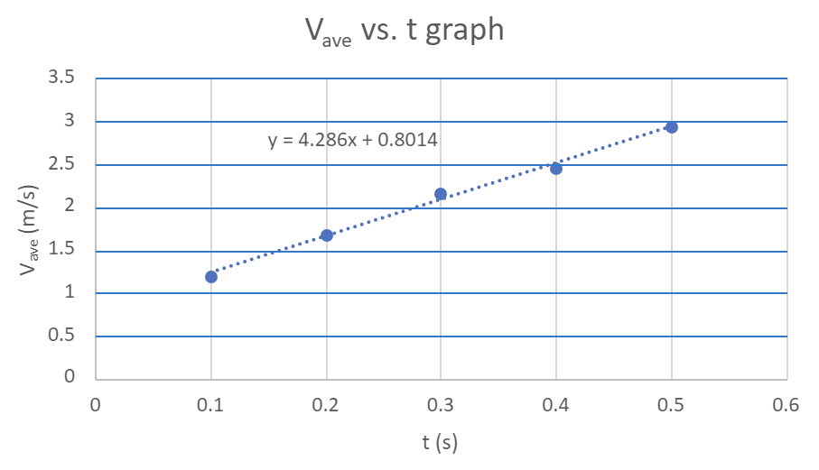

4. Vave vs. t for V4 at X4

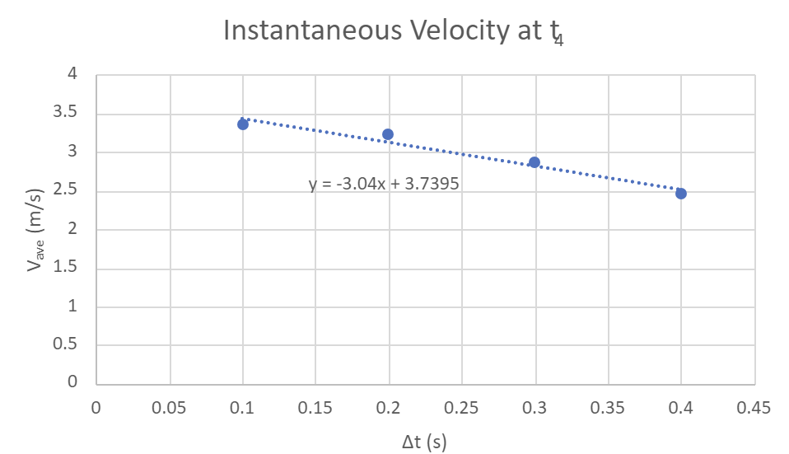

**CALCULATIONS**

1.

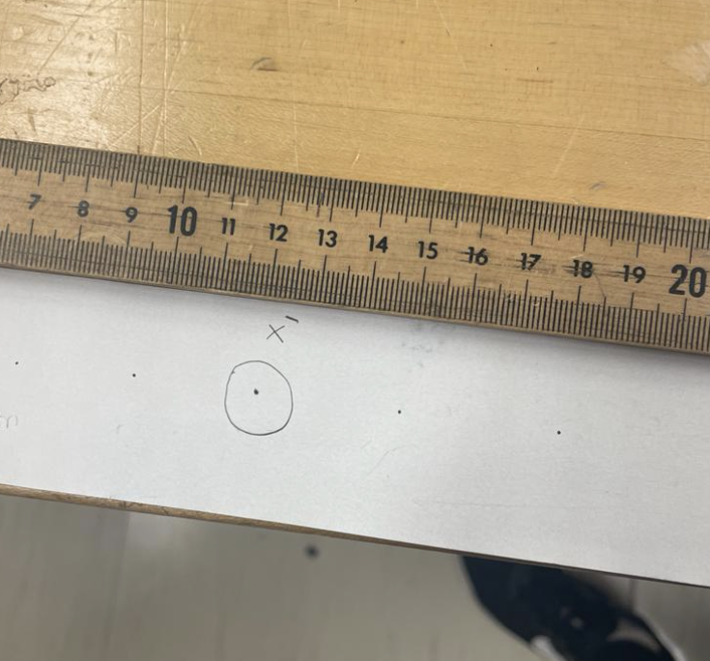

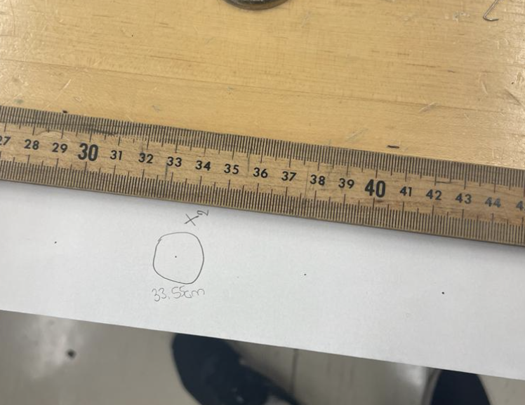

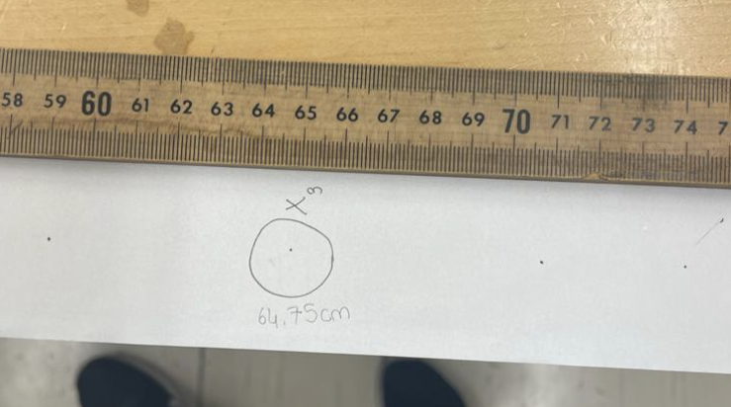

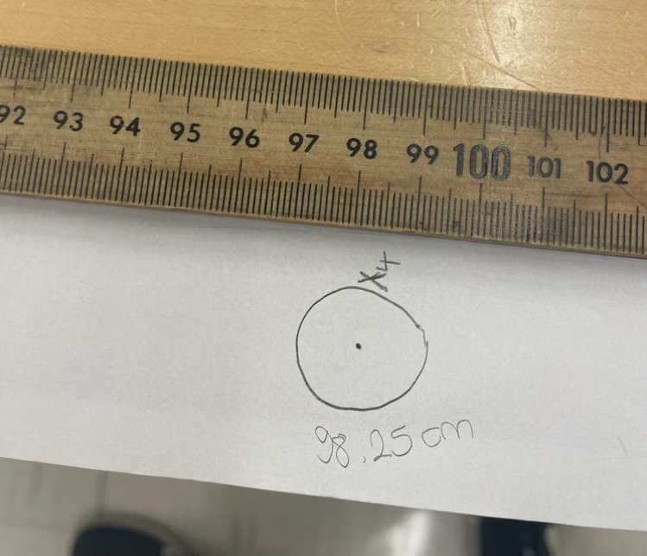

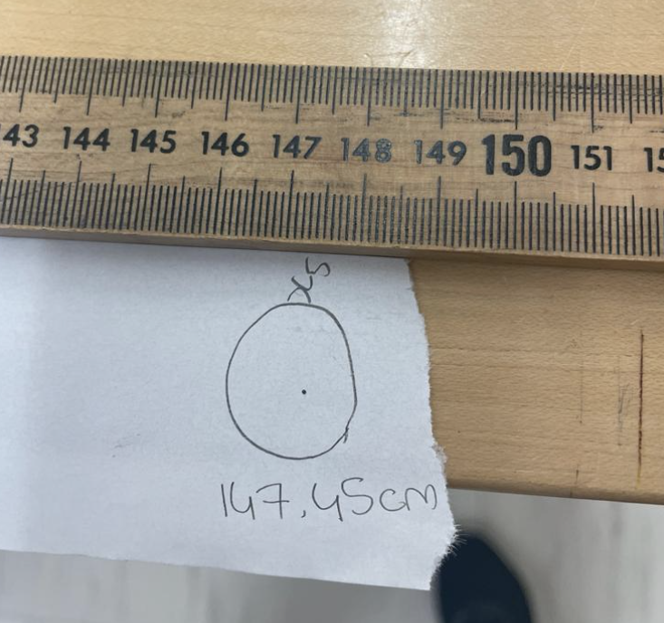

2)

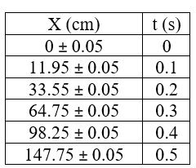

3)

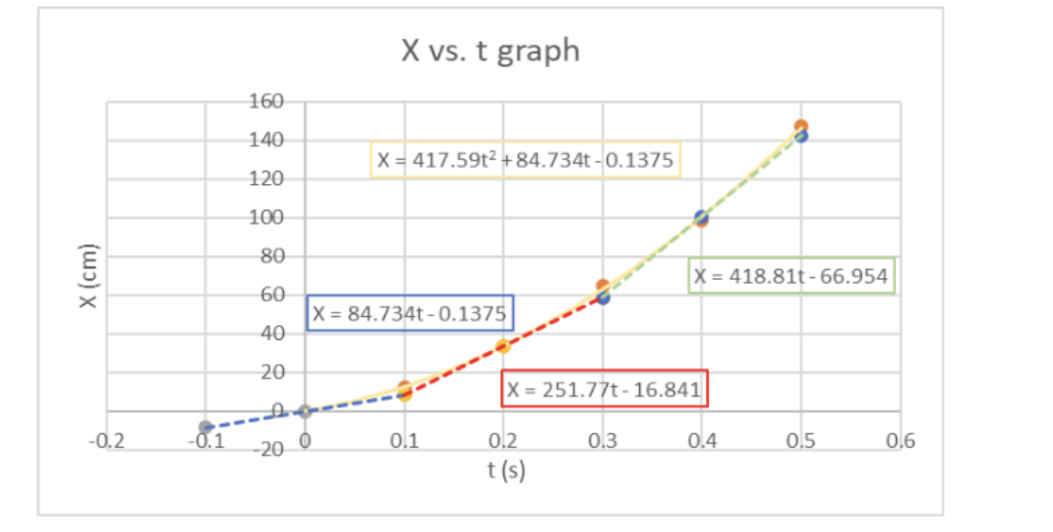

4)

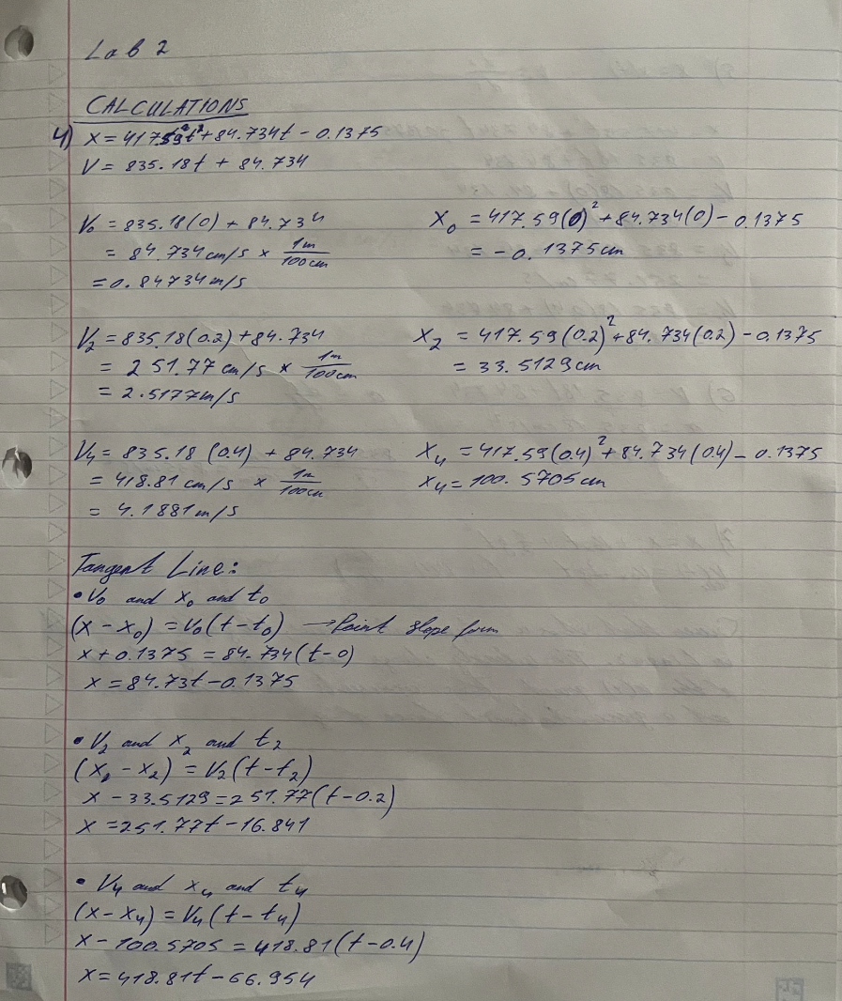

5)

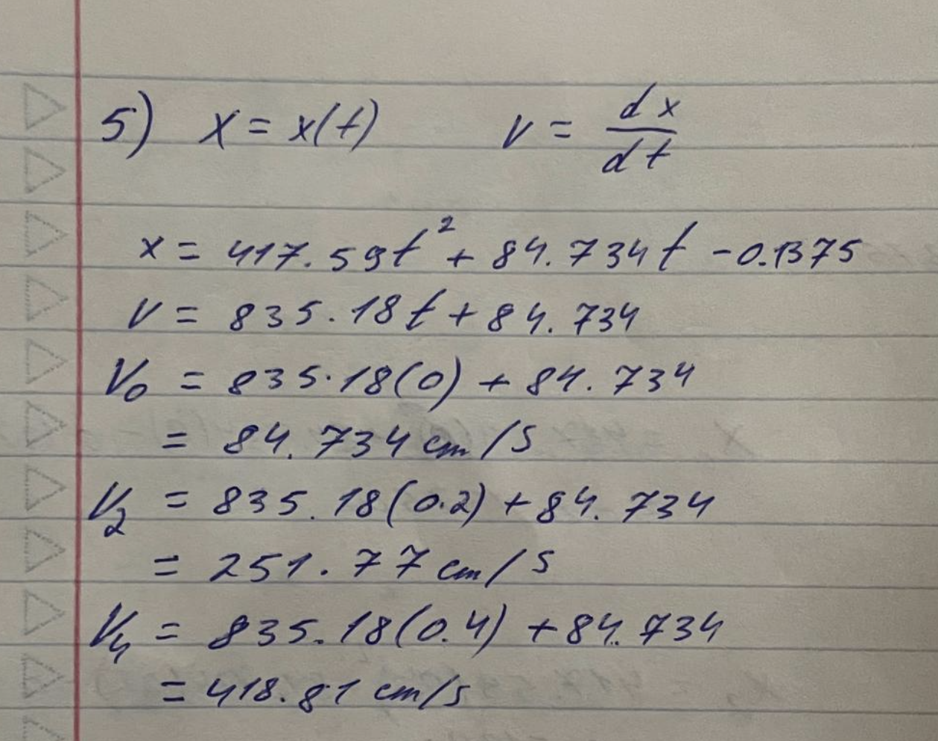

6)

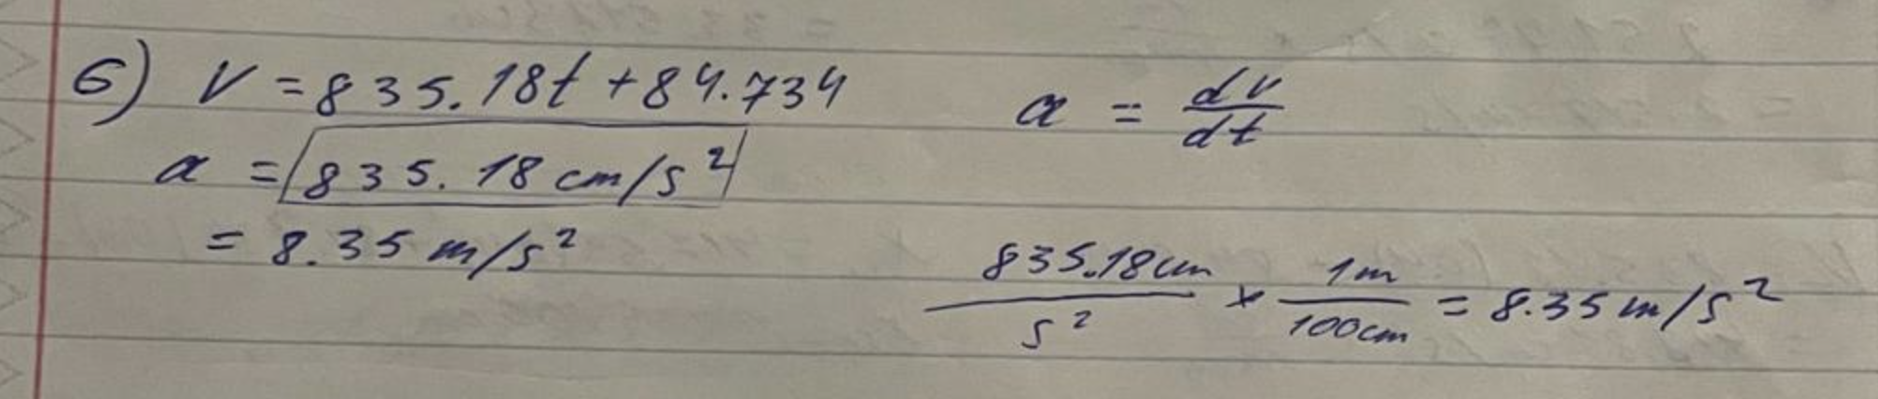

7)

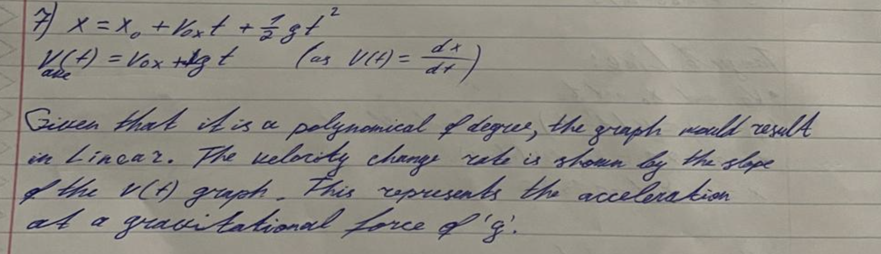

8)

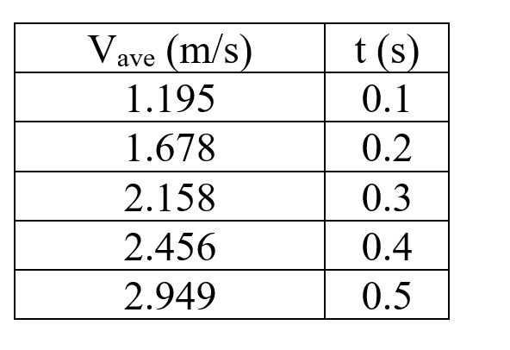

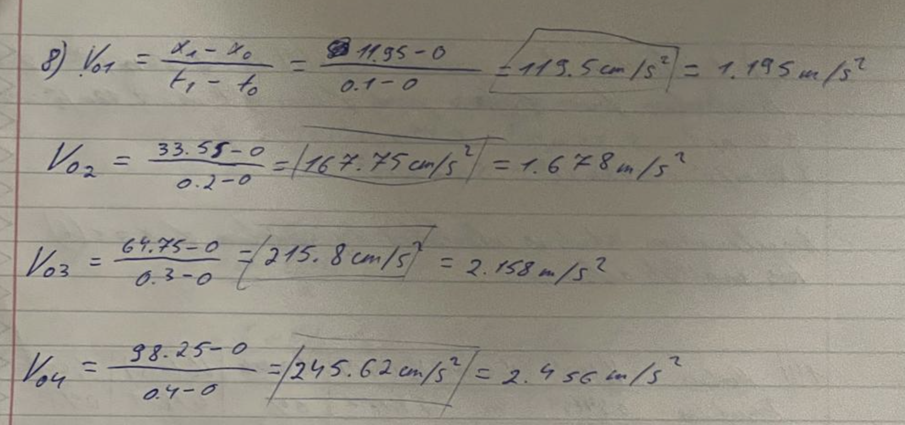

9)

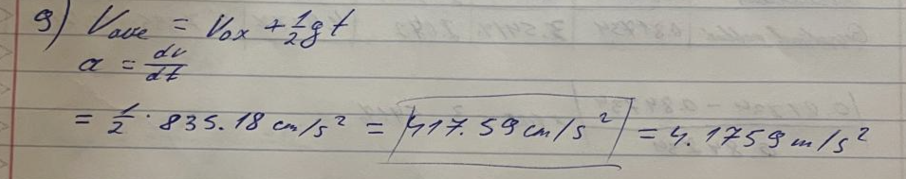

10)

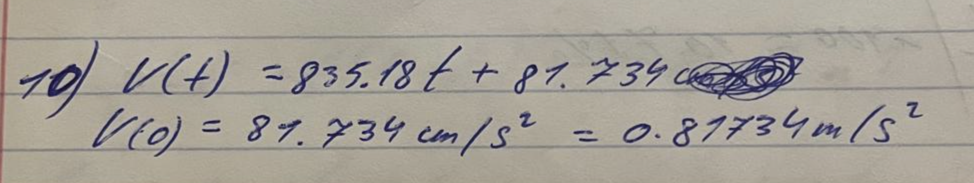

11)

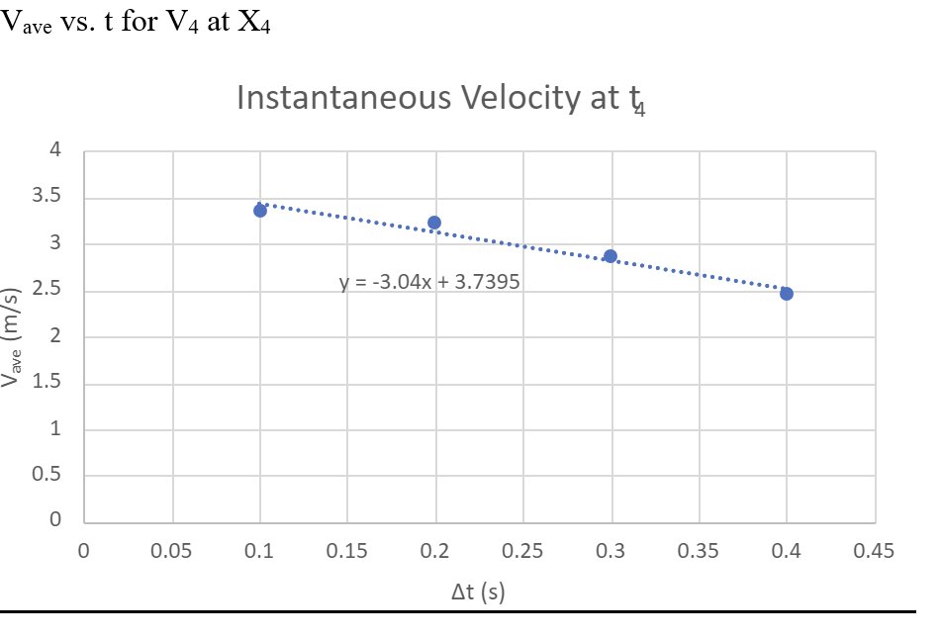

12)

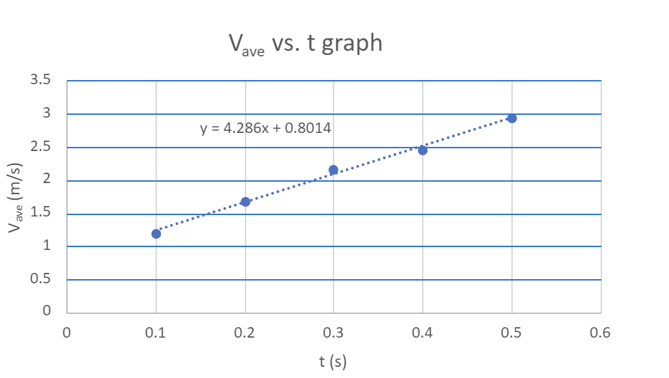

13)

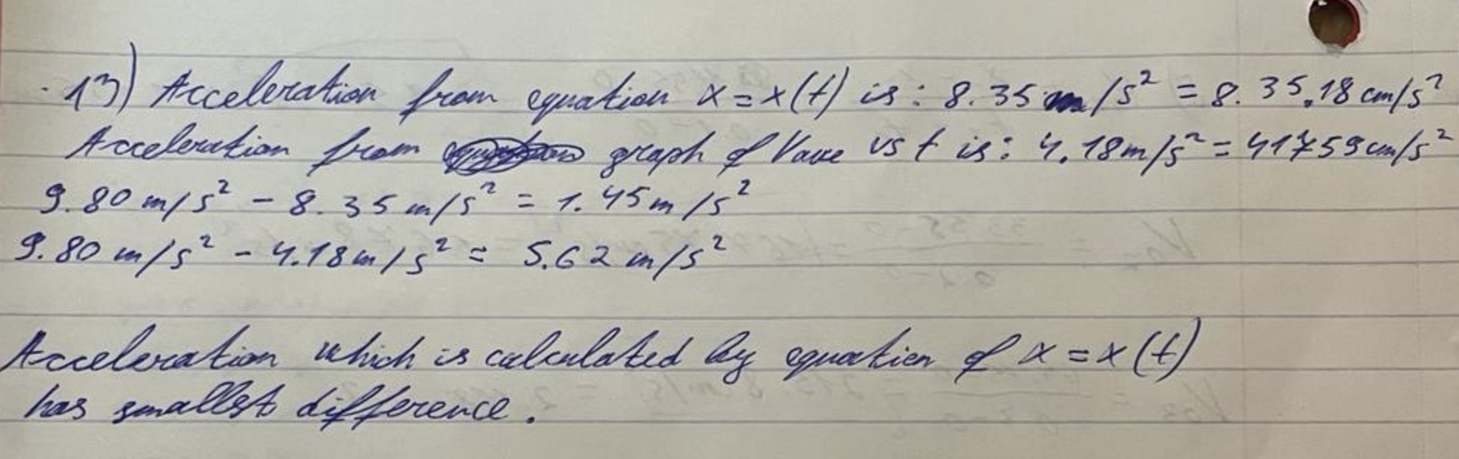

14)

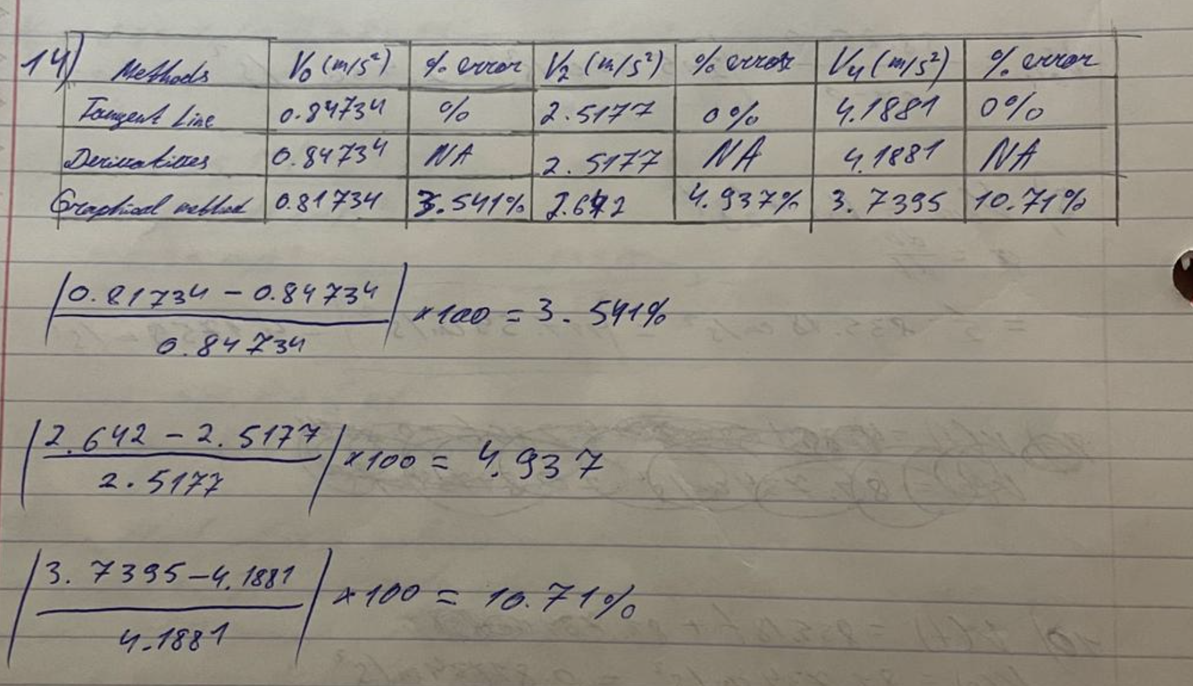

15)

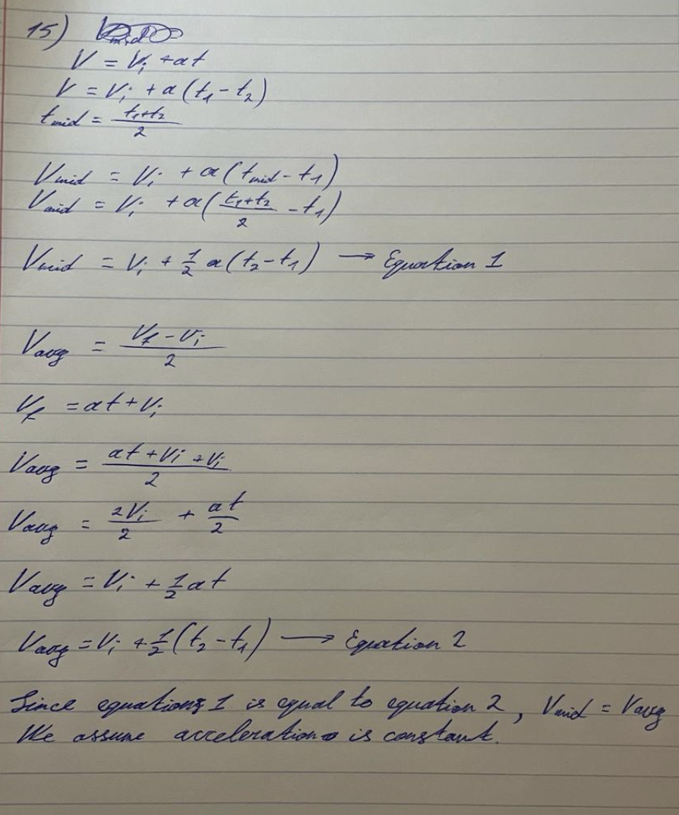

**CONCLUSION & RESULTS**

By analyzing free-fall motion, our lab sought to calculate the acceleration of gravity, or "g," and compare it to the estimated value of 9.80 m/s². Based on data and studies with the Behr Free-Fall apparatus, a 2-meter stick, and a spark timer, we concluded that the acceleration due to gravity was 835.18 cm/s^2. Systematic faults, specifically the misalignment of the Behr Free-Fall apparatus, which resulted in longer distances between spark spots and, hence, lower velocities, had an impact on this outcome. Comparing instantaneous velocities resulted in a bigger percentage of inaccuracy due to this systematic flaw. Furthermore, air friction-related random error affected our findings by decreasing acceleration and lengthening the time it took the "bob" to descend to the apparatus's bottom. As a result, the acceleration measured experimentally was less than the predicted value of g = 9.80 m/s². In contrast to the acceleration obtained from the graph of V(ave) vs. t, the acceleration computed using the equation x = x(t) showed a lesser variation from the predicted value of 9.80 m/s² when comparing multiple techniques of analysis. Our data show that although the experiment was effectively carried out, random and systematic errors—like air friction and equipment misalignment—had a substantial impact on the outcomes. When comparing the computed acceleration of gravity to the predicted value, these mistakes lead to differences in results. In addition, when monitoring the bob's location for every sixth spark for five data points in this experiment, random mistakes happened. These mistakes were probably brought on by irregular readings because of parallax inaccuracy as well as possible faults from improper instrument calibration brought on by earlier users.